1. Configure Classic Load balancer.

Go to aws consol – search ELB load banacer – click on load balancer ec2 feauture

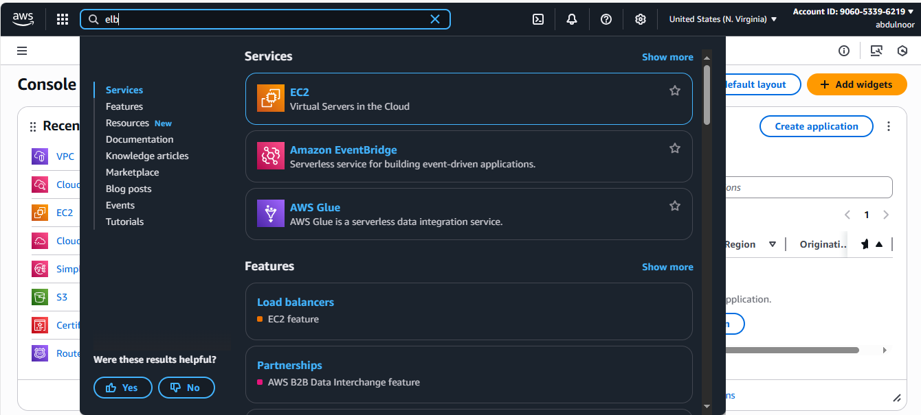

Click on create load balancer

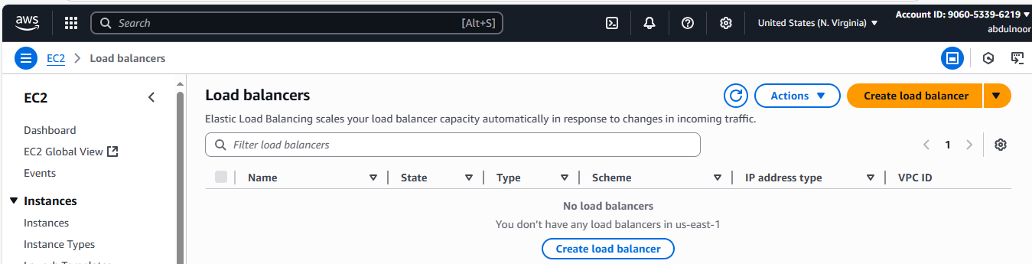

Again scroll down click on classic load balancer

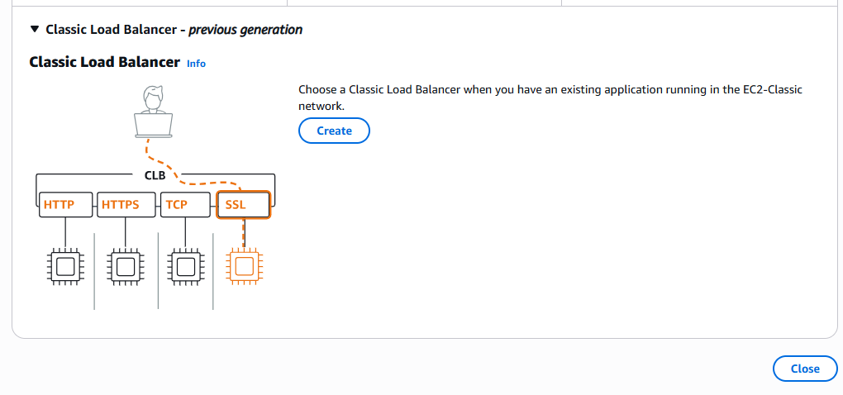

Click on create

Below Key point explanations:

Load balancer name or ex: classic load balancer

Internet facing : means public

Internal means that is within the subnet that is private. for internal loa balancing we can use them.

VPC : using deault vpc only

Subnet that is public subnet here using two public subnet az1 and az2

I have used 2 subnet or the deployment o load balancer and where are we going to deploy the loa balacer. Load balancer should be always in public subnet I you want to expose this to outside world. If it is private subnet , no use of creating load balancer.

Security group : deault

Thi clb listens protocols HTTP, HTTPS, TCP, SSL

For now iam using hTTP

If you want to use HTTPS then you need to configure your SSL certificate as well.

Listener protocol example just adding 80 at last



Instance protocol : means which instance we are going to map and which protocol is working and what is the port number of that instance (means application what we are going to deploy) in my case it is 80

Health check

We can configure ping path according to our application



Advance health check : here time is mention o health check

Instances : here we can add instance but as o now we don’t have any instance

Enable cross zone load balancer : means different availability zones are available then we can enable

Enable connection draining : Means for example If the instance is not healthy then after health check then it deregister itself.

Then check ones whatever configured and scroll down and click on create load balancer

Configuration

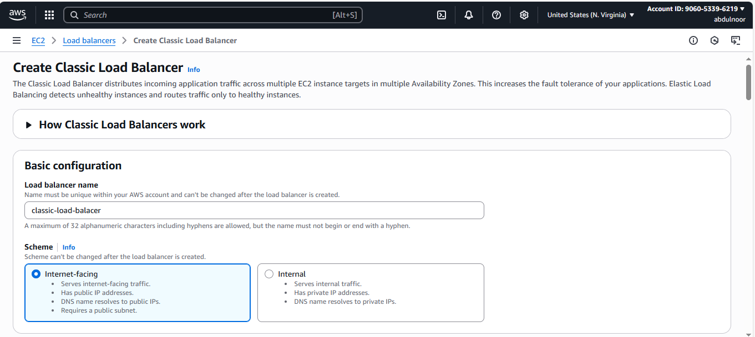

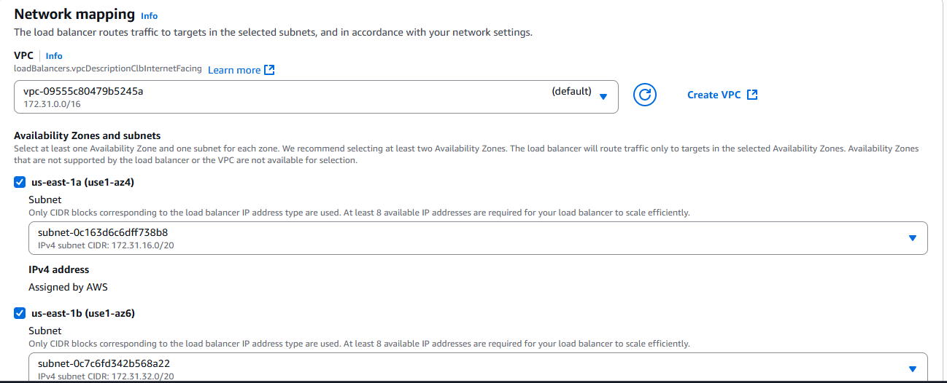

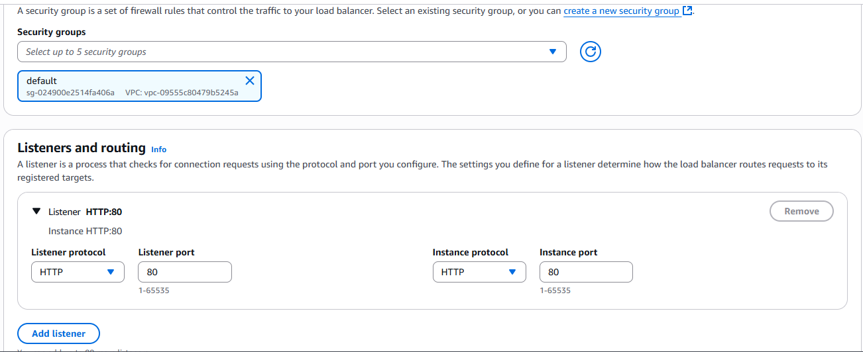

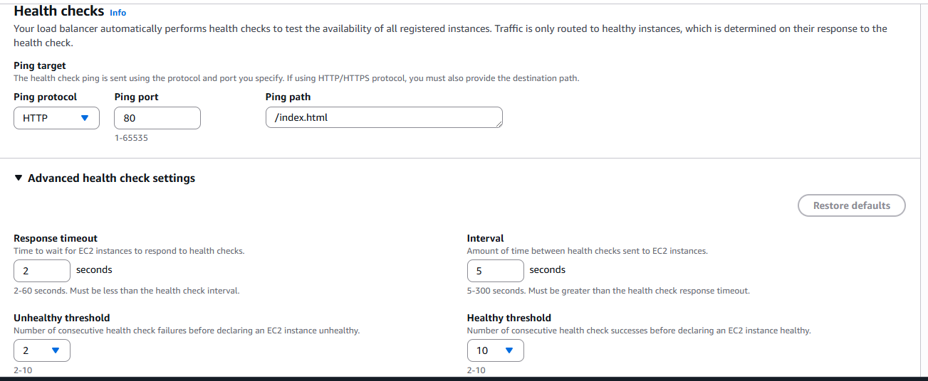

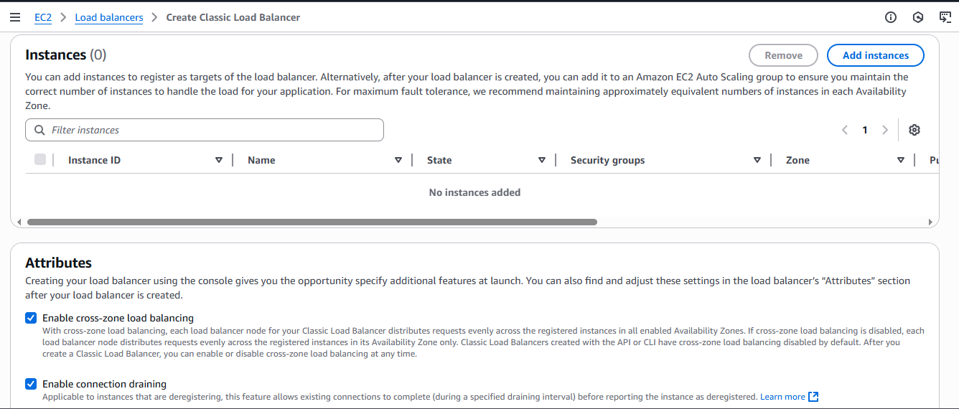

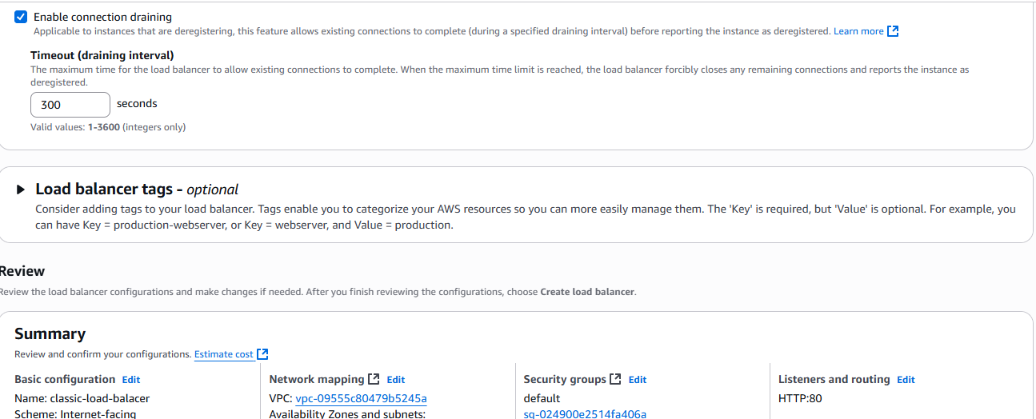

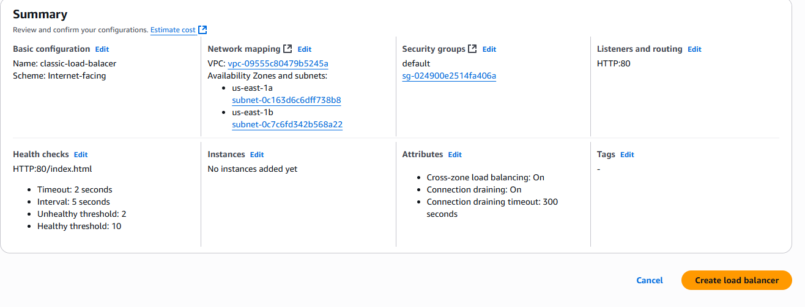

Click on the green

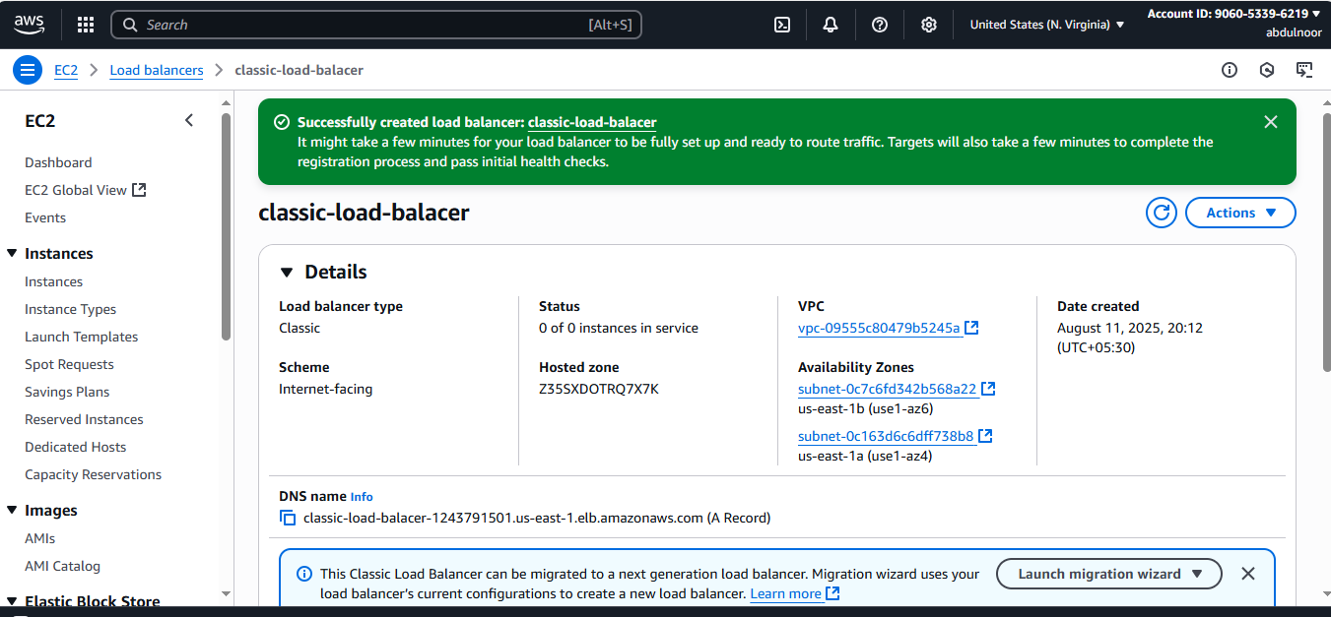

Here If you see status : 0 of 0 instances in service because we haven’t attached to instances

Now create 2 instances

Duplicate this page and go to eC2 – launch instance with same vpc and subnet which you keep or your load balancer and create another instance with second subnet.

And also add one script example

#!/bin/bash

sudo yum -y install httpd

echo "welcome to server-011" >> /var/www/html/index.html

sudo systemctl start httpd

click on launch instance

it will take some time to launch one server for us

Create another instance

Use the second subnet and change the script according to instance name but this is no need just or us to identify.

#!/bin/bash

sudo yum -y install httpd

echo "welcome to server-012" >> /var/www/html/index.html

sudo systemctl start httpd

-------------------------Now check our first ec2 server is running or not

Copy public IP and keep in browser

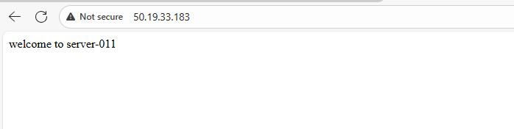

So the above is listening on port no 80 and it is trying to access the file from index.html



:80/index.html

Is our Ping path

So our load balancer will come to this particular location URLportno and index.html location

This location available it will consider as healthy if this location is not available then it will consider as unhealthy.

Load balancer

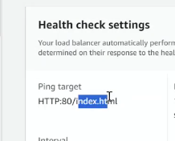

And check the second instance sever is responding or not test it …..

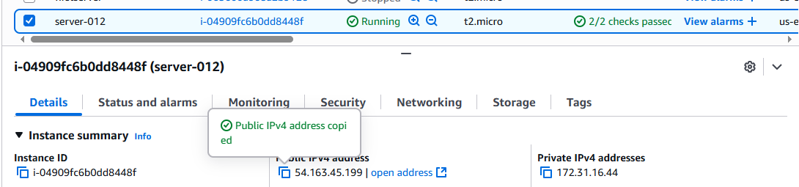



Ater the testing only attach it to the load balancer

Now go to load balancer click on Target instances and click on manage instances

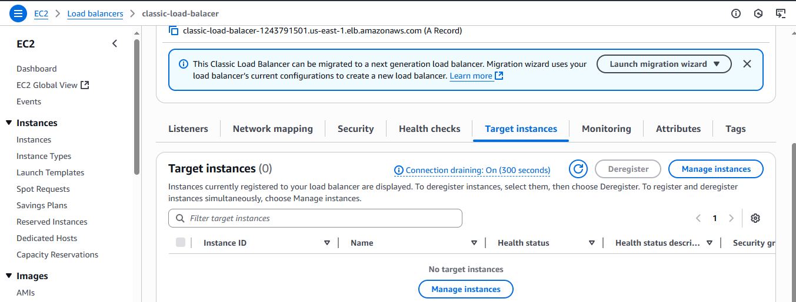

Select the instances

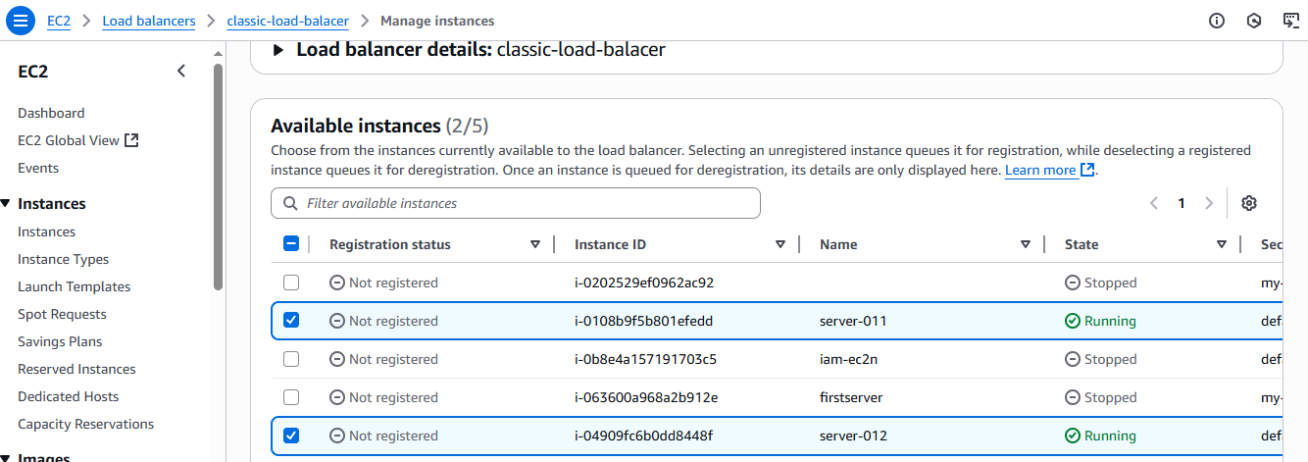

Click on save changes

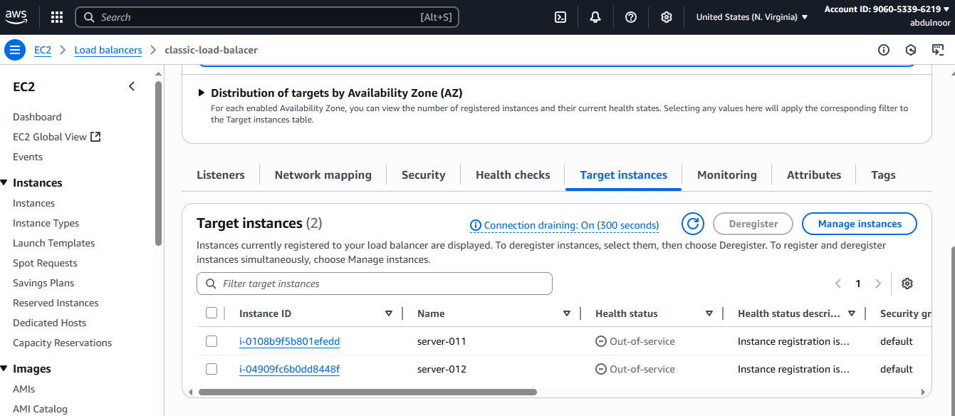

Still it shows the status 0 of 2 instances because it will take some time

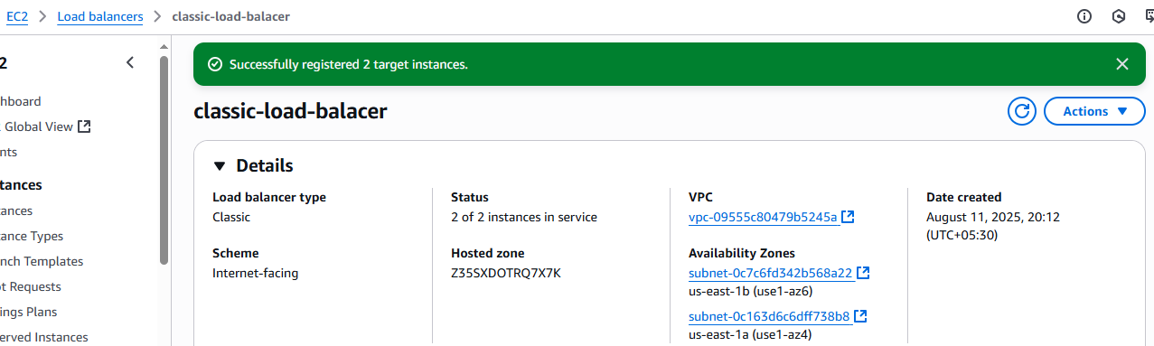

I you want to see heath check then come to the target instances scroll right

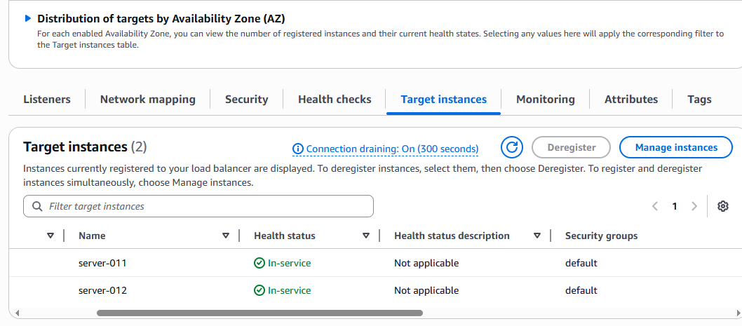

Now I want to access my load balancer. Means I want to acess my load balancer . there is no ip address . copy the DNS Name and paste it in the browser then it will go the request EC2 and then I you reresh then it reuest to another EC2 like this according to LB.

Go to load balancer

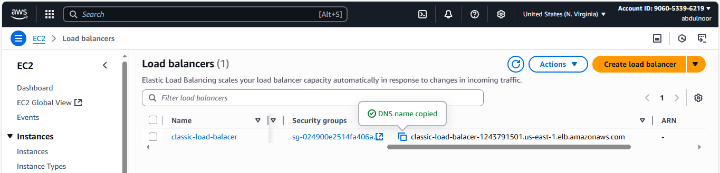

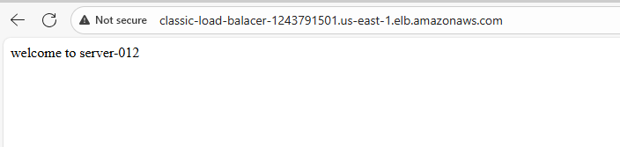

Refresh



When you are refreshing it is changing the servers means which algorithm based it doing at backend.

That is : Round robin algorithm

Note start : just or information you can modiy the message welcome to server-011 to both the servers also suppose by entering entering into instance. This is only for testing purpose only. How many servers are vailable you can say by seeing health check and target instances and status only in lB.

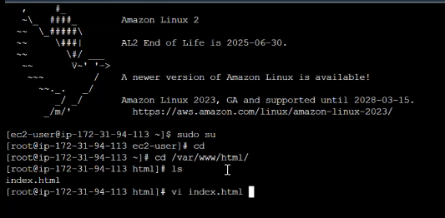

…………………………………Note end

If you are keeping https in the browser then it will not response because we haven’t used https as our listen in load balancer configuration. We have only used http as listener.

We can only configure any listeners for classic load balancer

Scenario : lets delete the index.html which is available in server-012

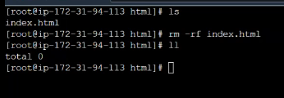

Go to load balancer and refresh this

See here only 1

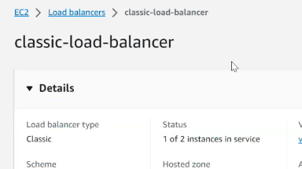

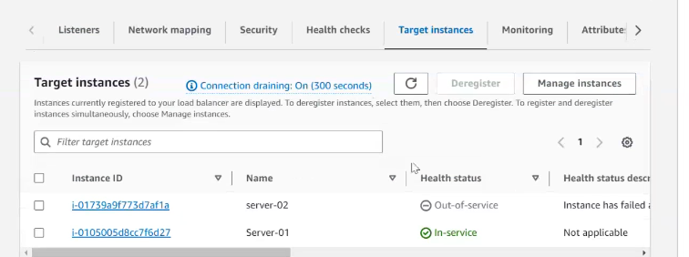

Because health check has been failed.

Scenario : If you have one more other application and you want to use loa balancer for that application then I need to create one more CLB and I need to attach the instances to the CLB.

The is the END OF CLASSIC LOAD BALANCER ………………………………………..

***IMPORTANT Note below***

How many users accepting this estmation done an based up on that they will configure the number of EC2’s . Apart from that we have auro scaling group. Why do we use – If the cpu utization more than 70% then it will automatically scaleup. And ASG configure below the load balancer and ASG will help us to create the new instances for us.

2Q) Configure Application Load balancer?

What is the use of ALB?

On which protocol it will work : http and https

(Let me delete this classic first)

Click on create load balancer

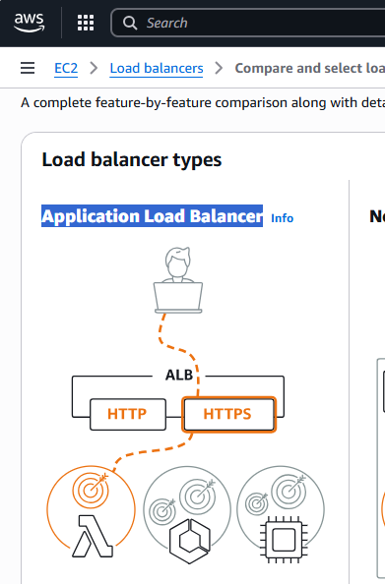

Cleck on create

Scenario : If you have one more other application and you want to use loa balancer for that application then I need to create one more CLB and I need to attach the instances to the CLB.

But where as in Application load balancer, this will help us to create multiple listners. Means our LB can listen on port no 80, 81, on different

Ex:

Here in below target group names are defined or ex: imaged, docs, info

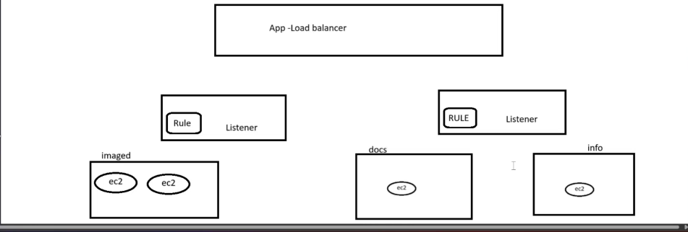

Application lB is working on the protocol HTTP , HTTPS this is first thing

And then we can configure multiple listeners to ALB and then we have something call RULE. So what this RULE will do , this will decide which particular target group the traffic should be redirected. Here in our scenarip 3 target groups are there. So here it doesn’t matter how many instaces are there inside this target group. So what will happen ……a user is trying to acess the application

dns-app-lb.com:80

to this particular url , it will reach to the LB, and it will come rulebcz here listener port no as 80. In RULE we configure as images then it will redirect this to particular target group (images). In this target group howmany instances are there will responsible to reply back. Below is image is updated

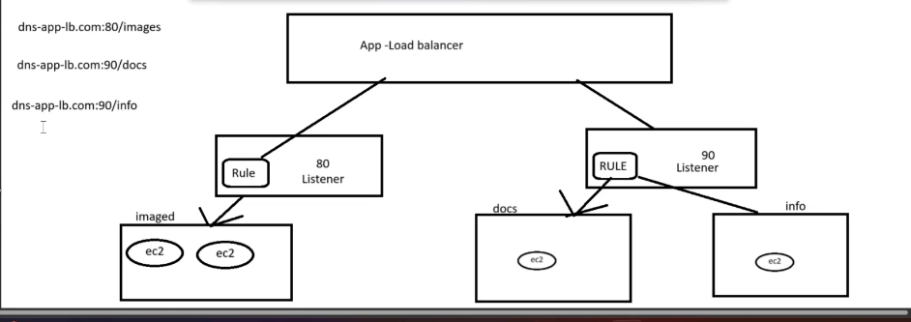

For ex: I the user is trying to access DNS-app-lb.com:80 or dns-app-lob.com:90 now where the user request to be redirect. I he is not specifying any path prefix (ex: images are path prefix). To redirect at least haveone deaault target group , without this it will not allow to create load balancer. Like home page example.

In our above image example 2 dierent apllications attached to one LB one is working on 80 and one is working on 90 means If we have 5 dierent applications then we can use the same LB and we can add diferrent listeners and diferent Rule and manage the traffic. No need to create diferent LB’s.

But where as in classic if you have 5 applications in our prject then we should create 5 LB’s to manage the traffic.

So that’s the advantage of ALB.

Now create one target group

We can keep health checks as /

Means root

Or index.html

Or any

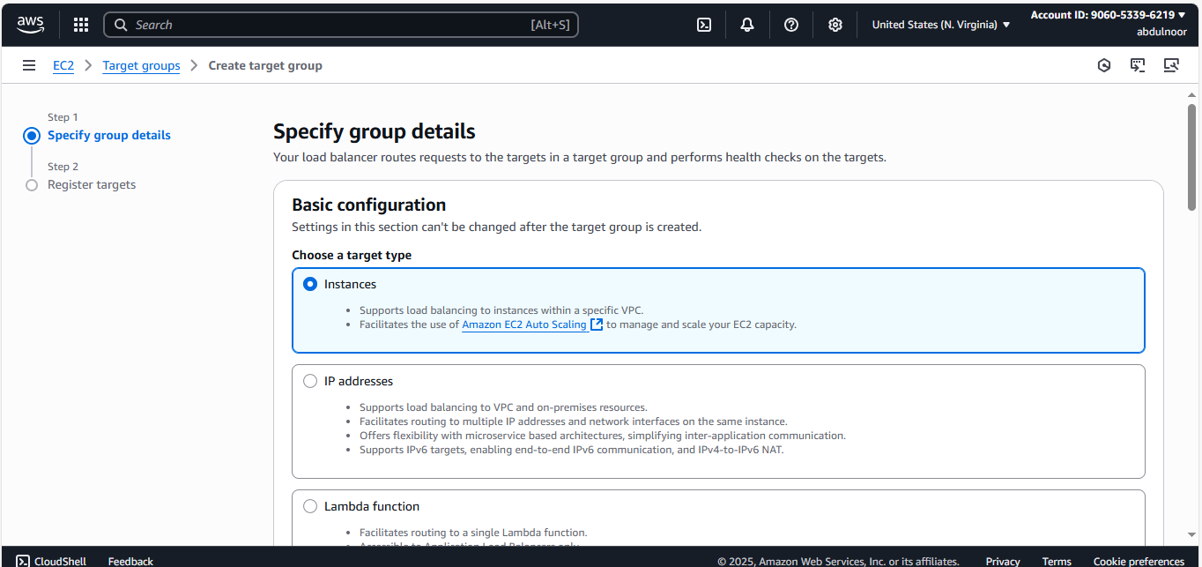

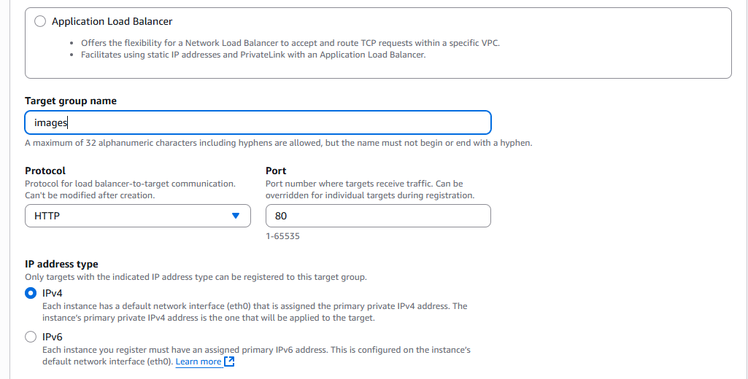

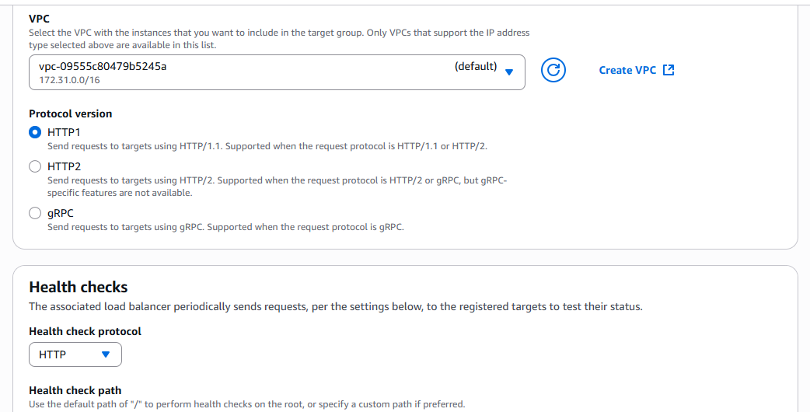

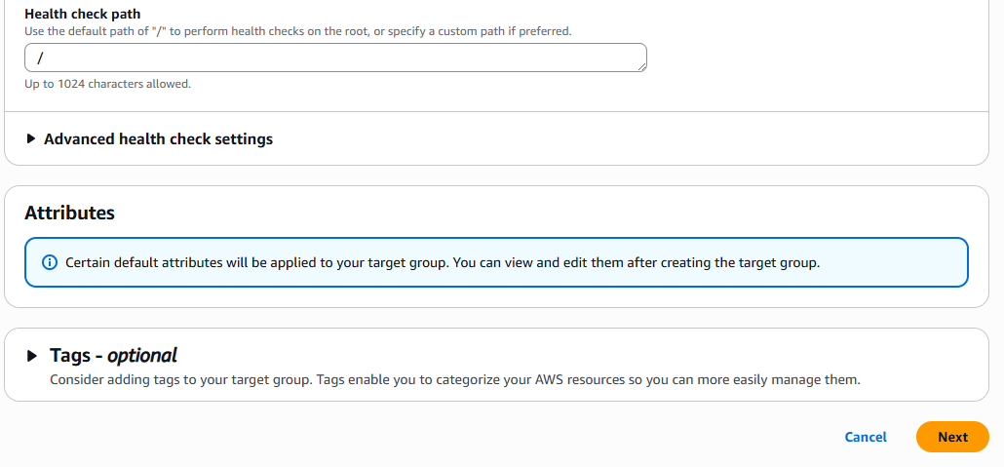

Click on Next

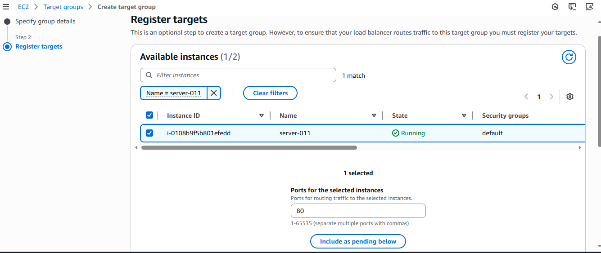

Click on include as pending below

And click on create target group

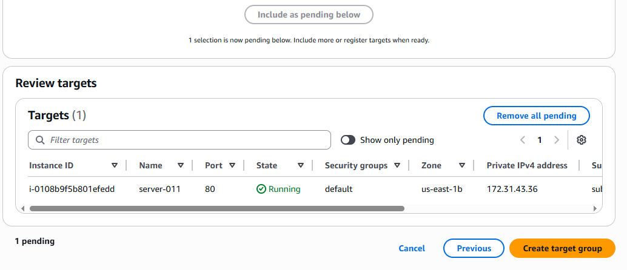

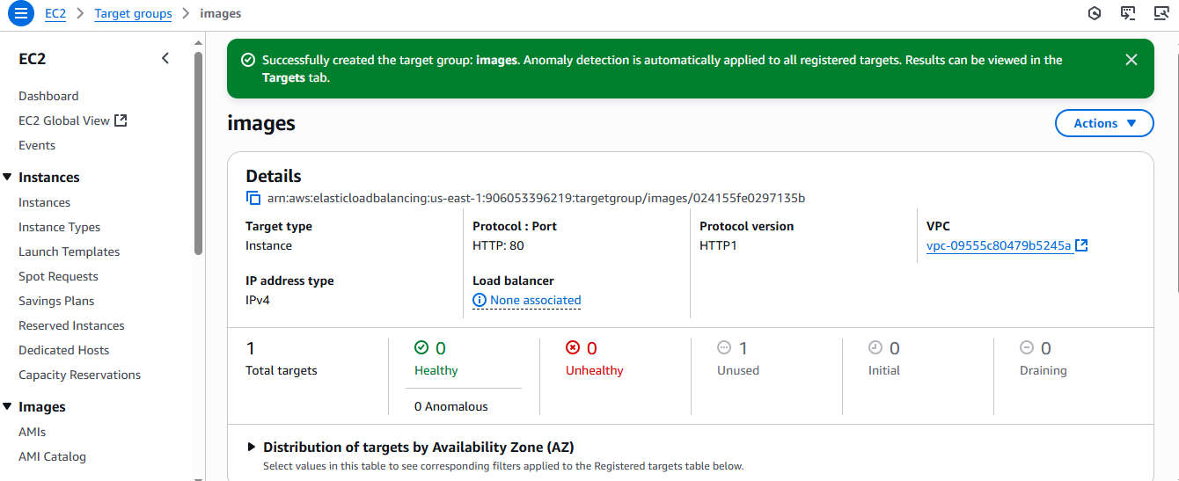

Scroll down left scroller

Click on load balancer. Here we haven’t create the LB

I you see the target group – images – one instance is available

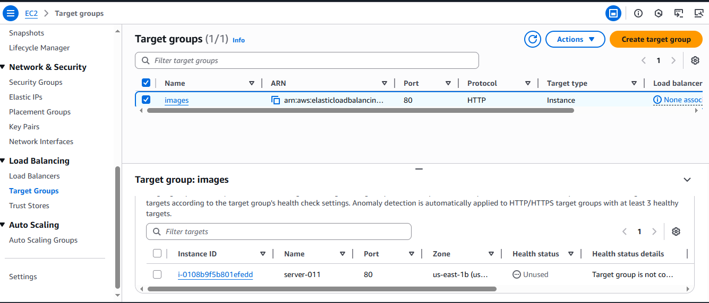

See one target is assigned to the images and it is unused means not used by anyone

Now Create one application load balancer

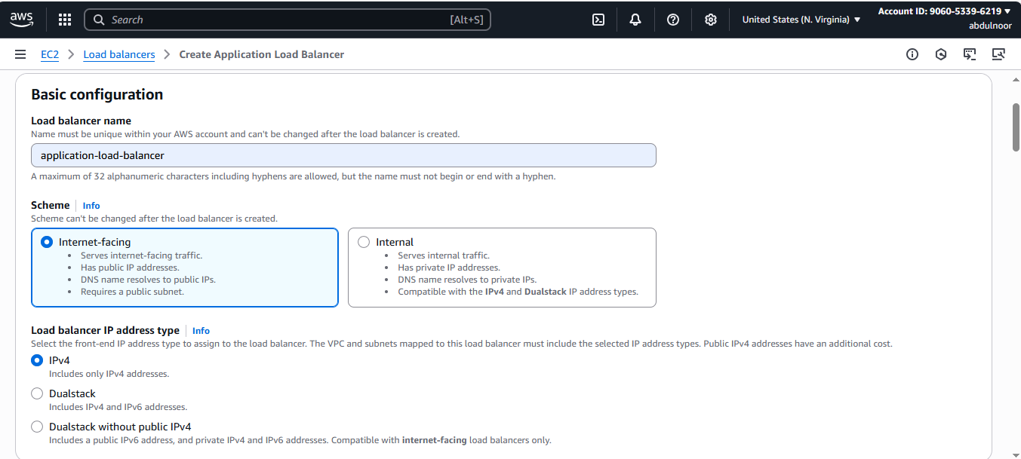

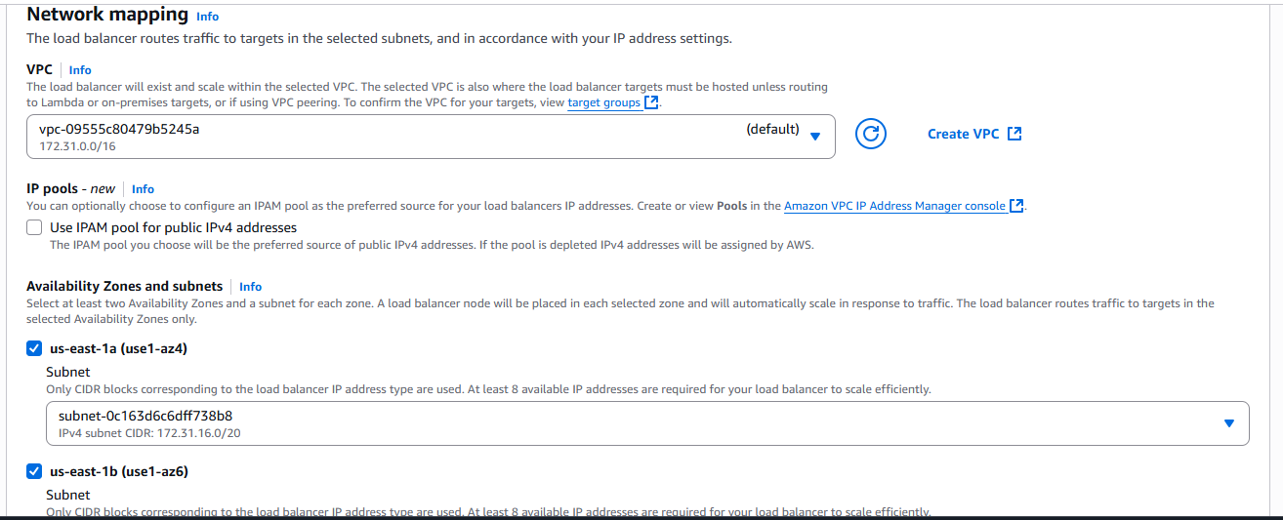

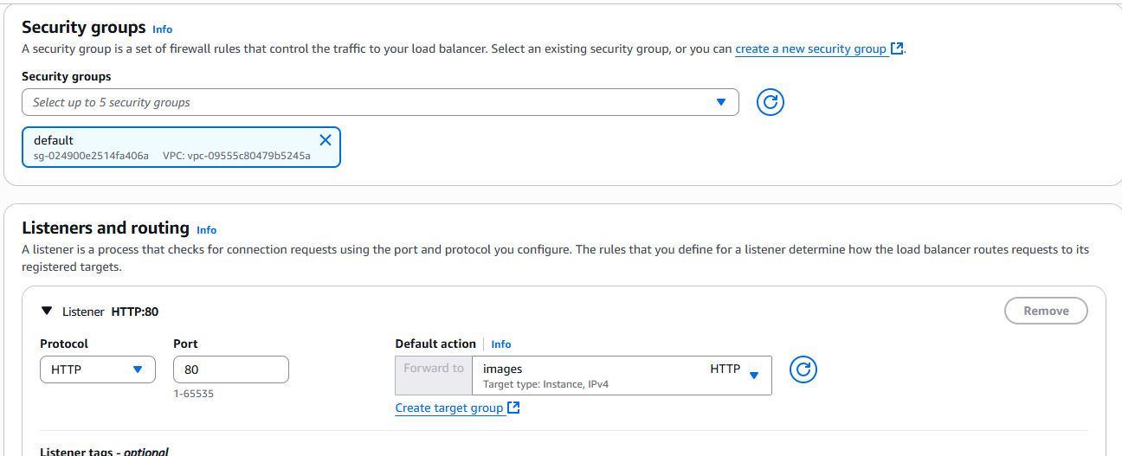

Click on create load balancer

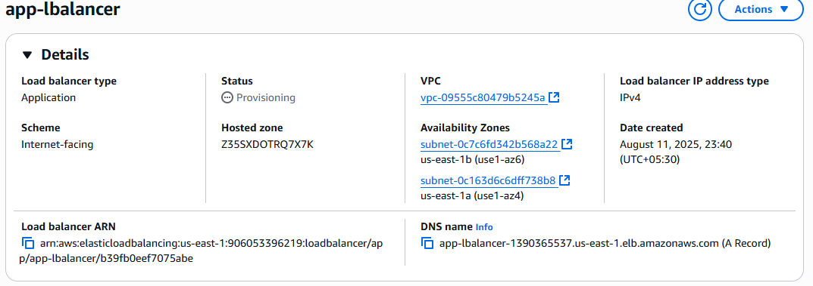

Go to target groups

It is at initial status. Means trying to connect our load balancer

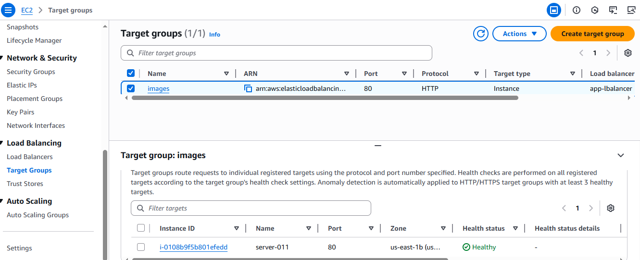

Now go to the load balancer copy the DNS and keep it in browser hit enter

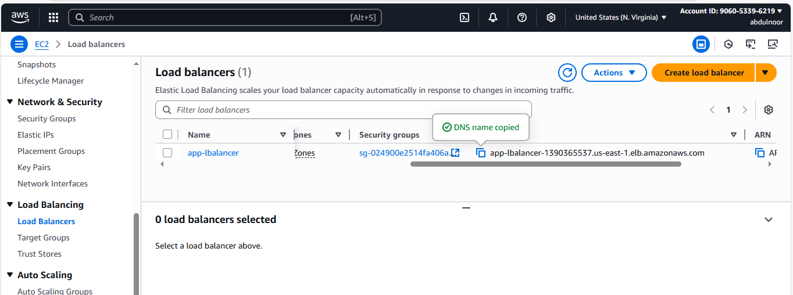

It will response If you keep in the browser and hit enter.

Now my requirement is images



This is nothing but prefix. Means I wa nt access my application rom the particular images.

Above I created default page withput adding rule.

Now I want to add one RULE that, this should redirect to the request based upon rule. If someone is trying access based upon images it should work or us.

As of it is not working

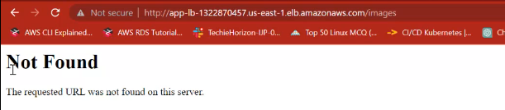

First connect to EC2 instance server-011

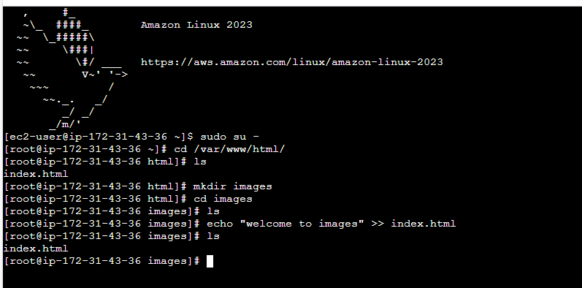



Along with public ip/images/

Then it is responding

It mean prefix is working at my application level.

Go to load balancer

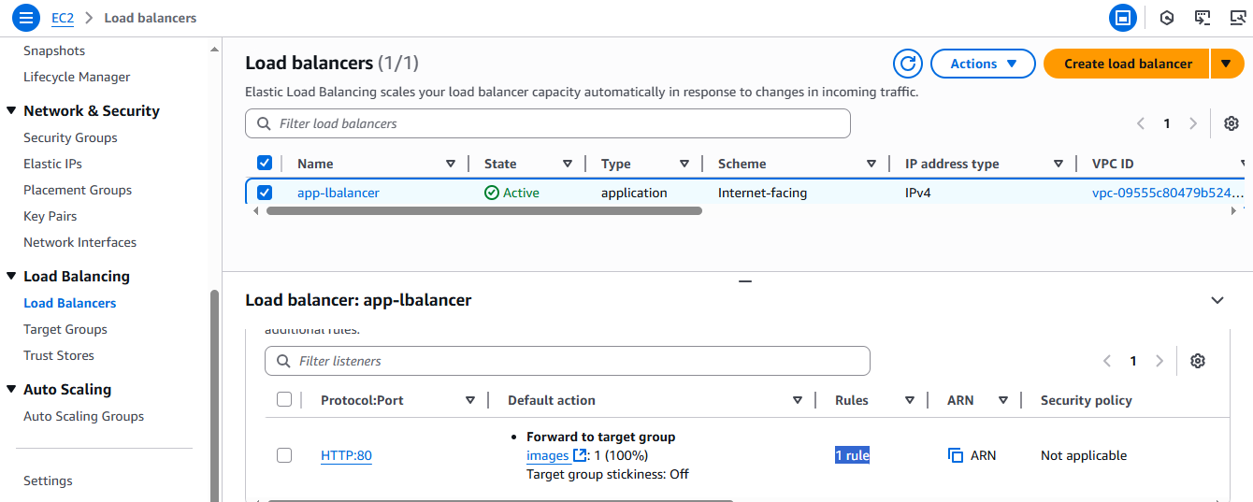

Click on Rule

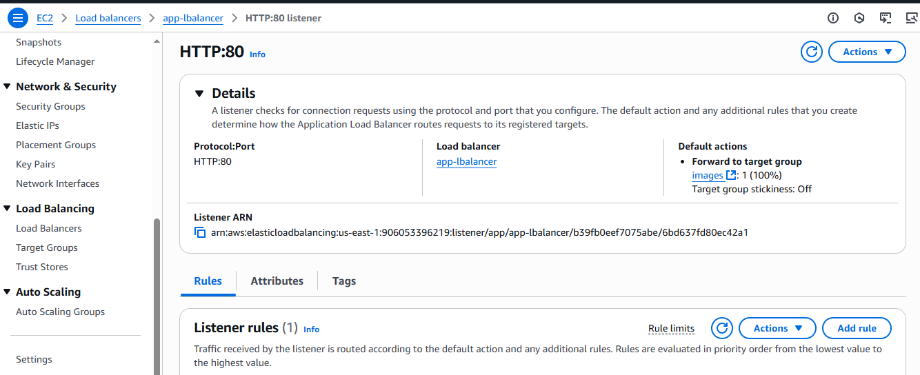

Then Add rule

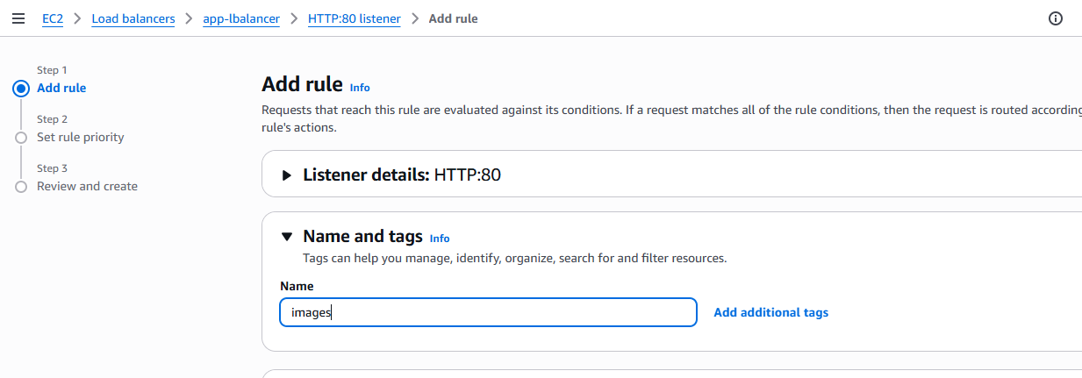

Click on Next

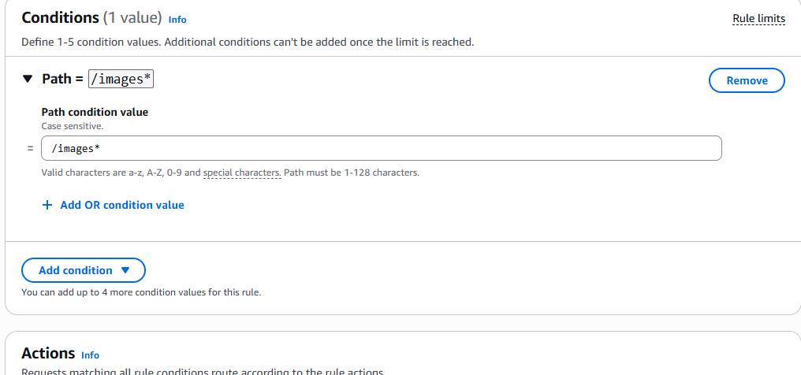

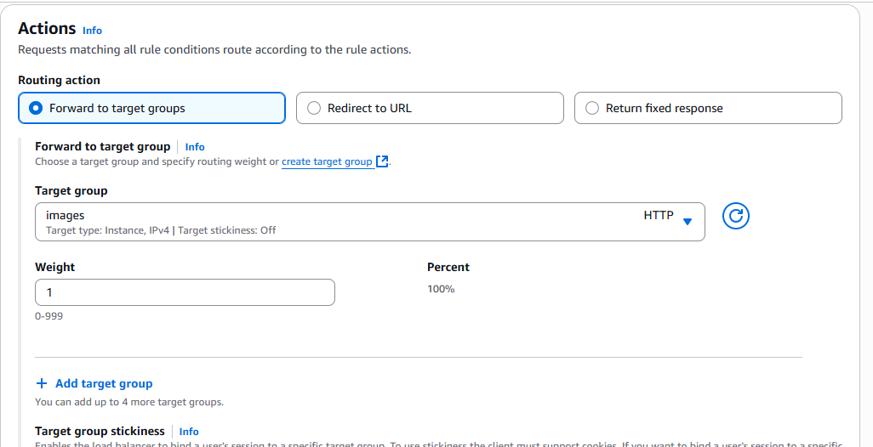

Click on Next

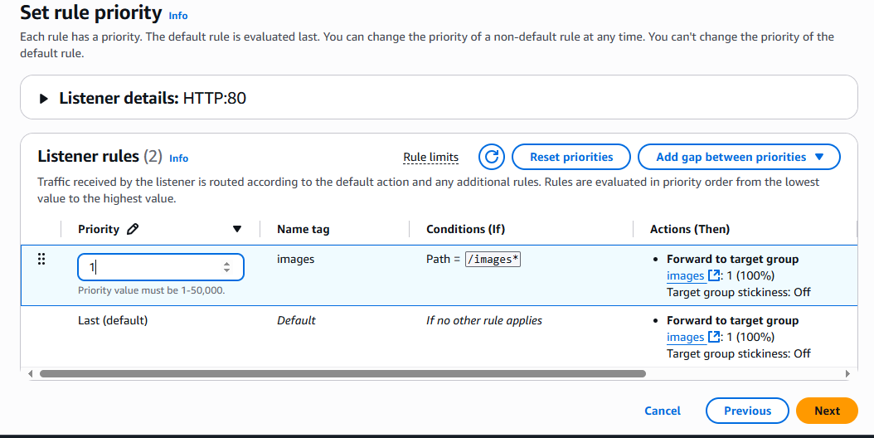

Click on NEXT

Click on Create

Now we have created one rule that any reuest to port no 80/images should be redirected to the assigned instance. Menas we have only 1 instance assigned and in that we have 2 application. One is deault.index.html and another is welcome to images.

Copy the Load balancer DNS/images/ hit enter in browser





Without prefix if the user is trying it will redirect to home page.

3Q) Configure Network Load balancer?

What is the use of NLB?

On which protocol it will work : tcp and udp

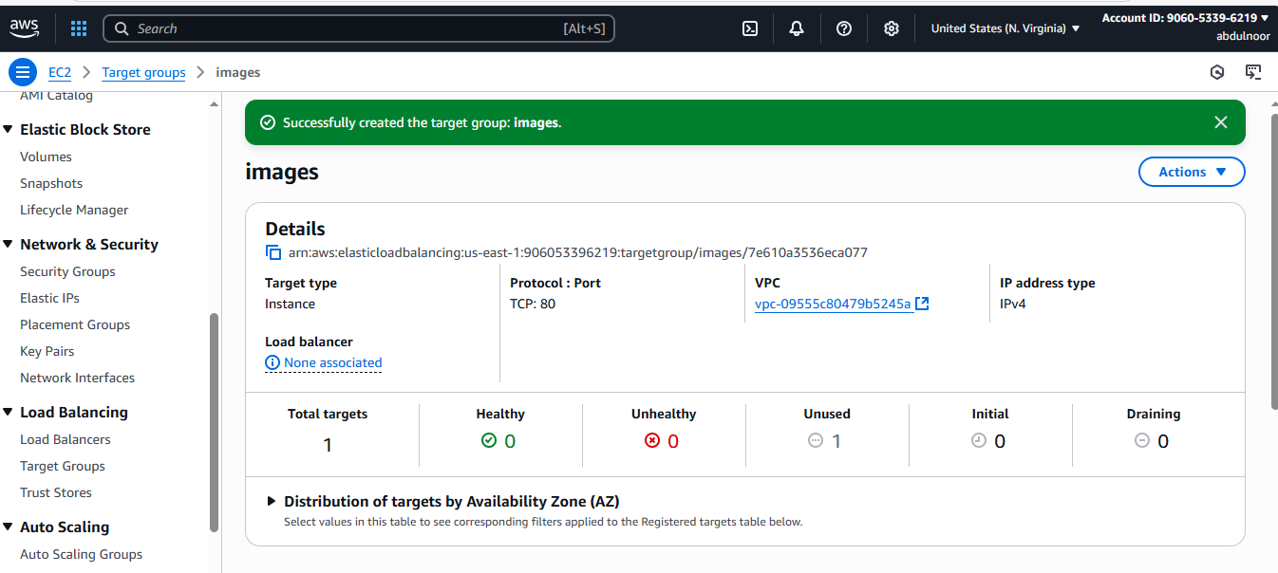

Create Network Load balancer

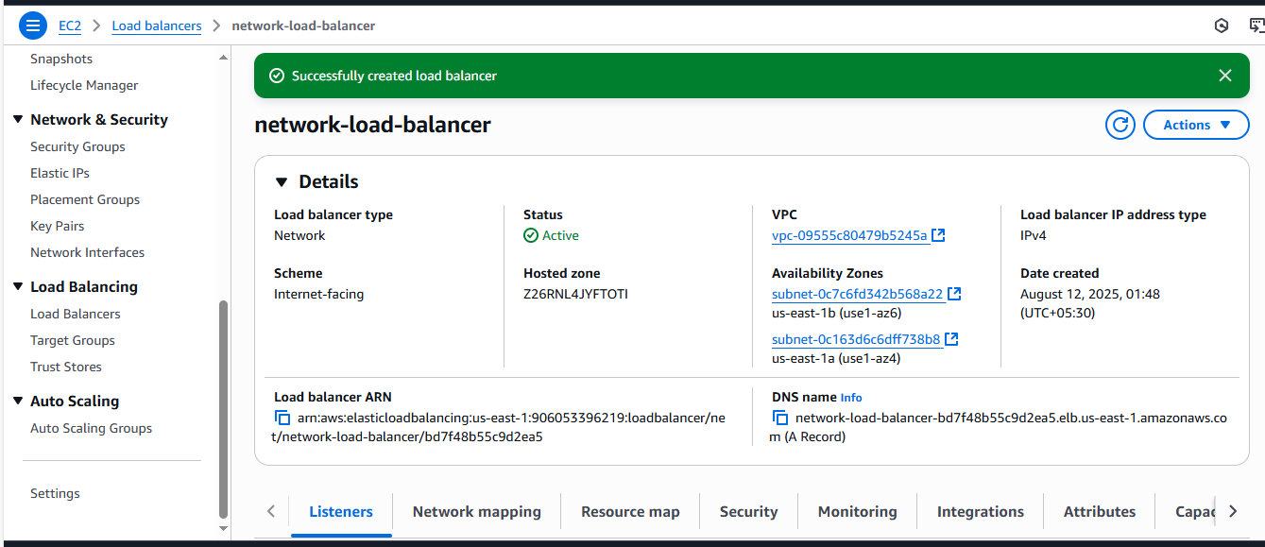

Go to LB – copy the DNS and keep in browser and hit enter



Now my requirement is



So or this create a Rule ex: images

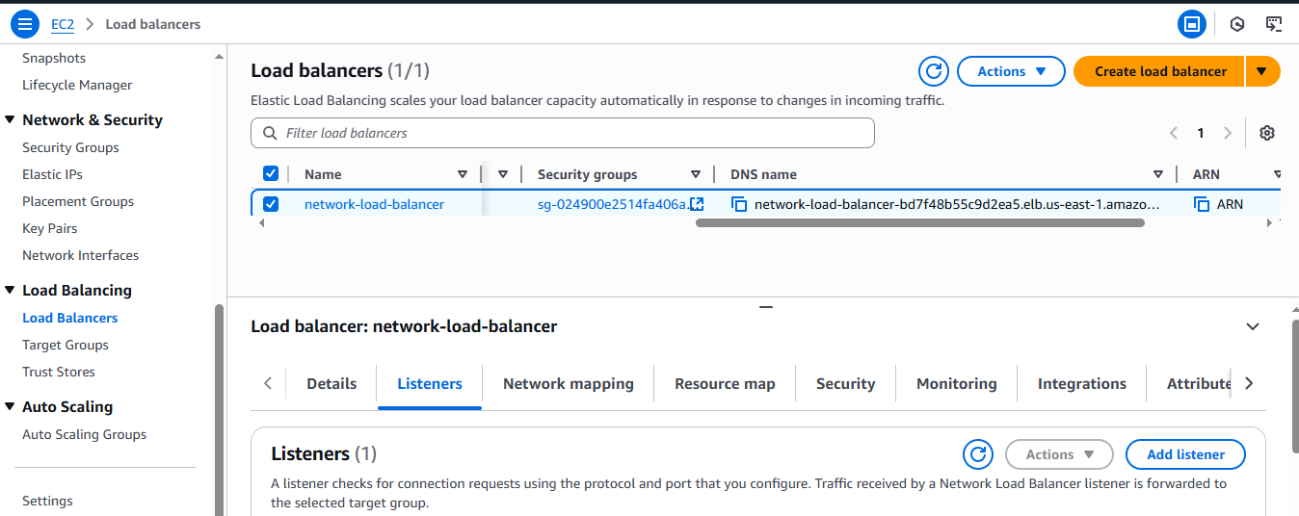

You’re not seeing a **“Rules”** tab because you’re using a **Network Load Balancer (NLB)** — and NLBs simply don’t have Layer 7 rule support like an **Application Load Balancer (ALB)** does.

Just copy the DNS o load balancer and keep along with preix images



4Q) Attach SSL for application load balancer

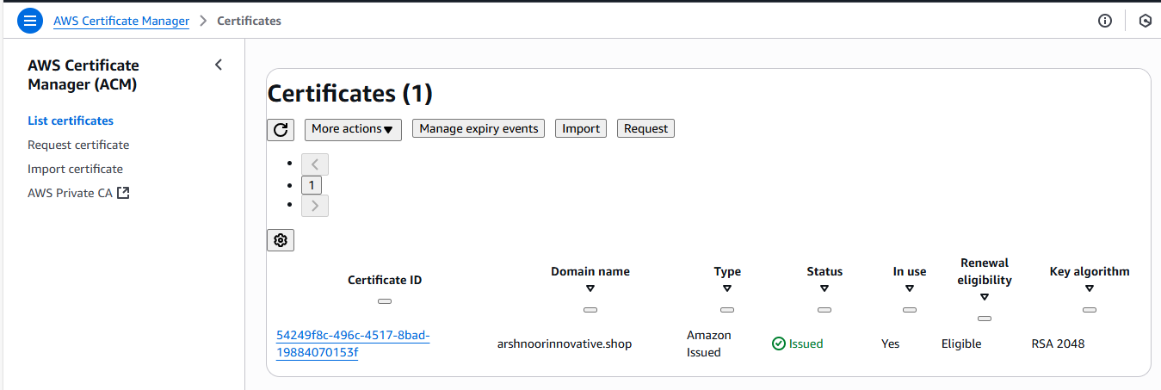

Click on Request Certificate

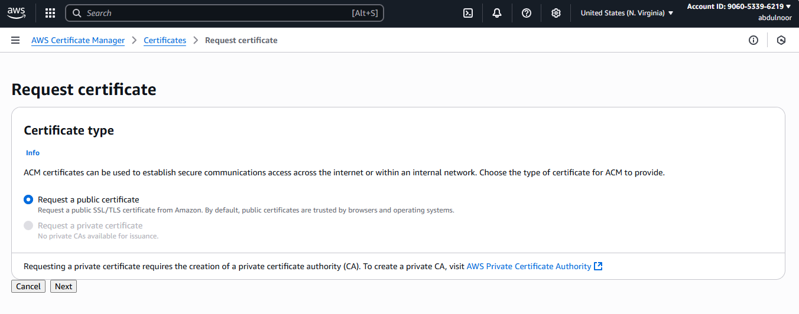

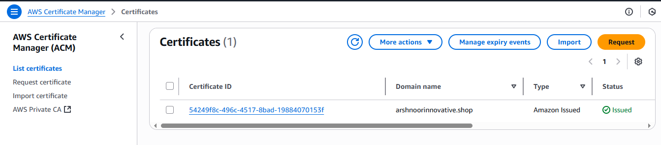

I had already

Go to load balancer and select ALB.

Go to listener tab and add or edit the existing protocol to HTTPS 443

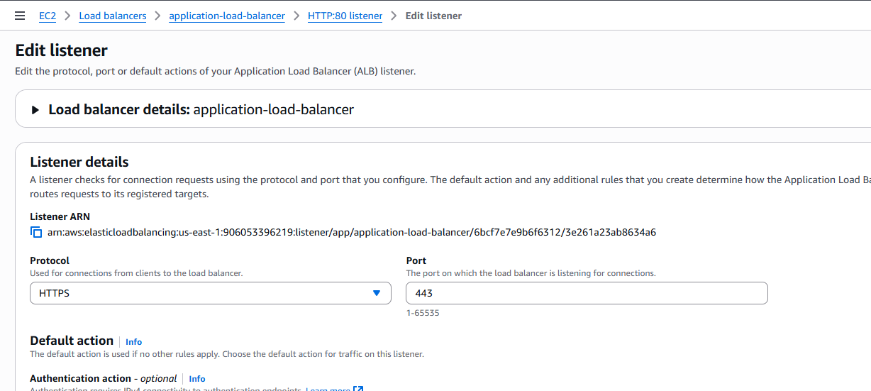

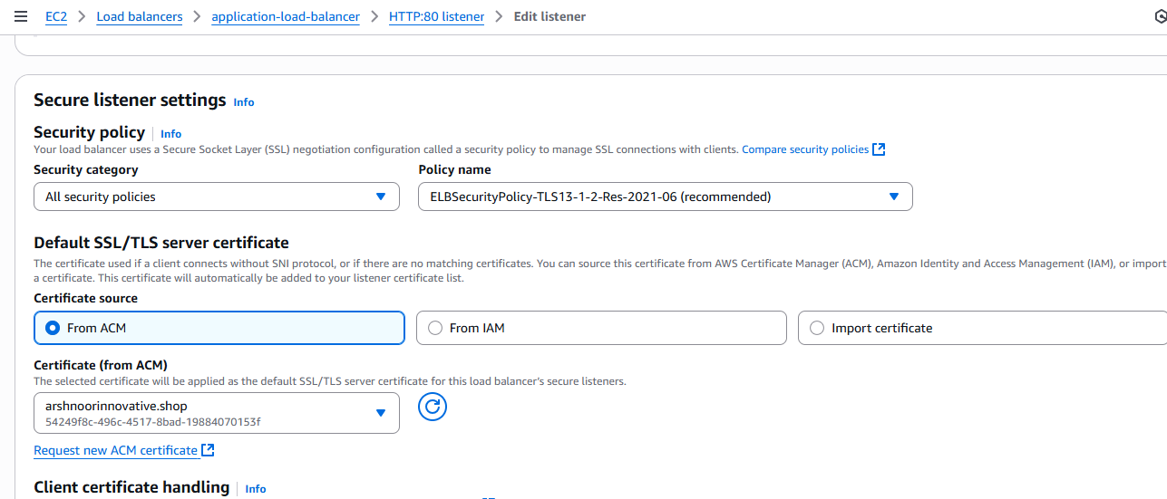

Click on save changes

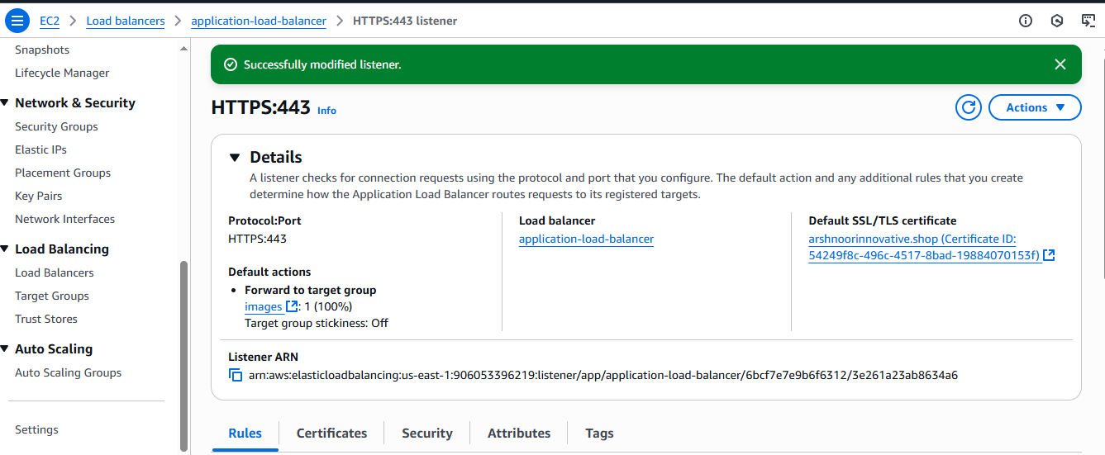

SSL certificate shoul be issued in the same region of ALB region.

5)

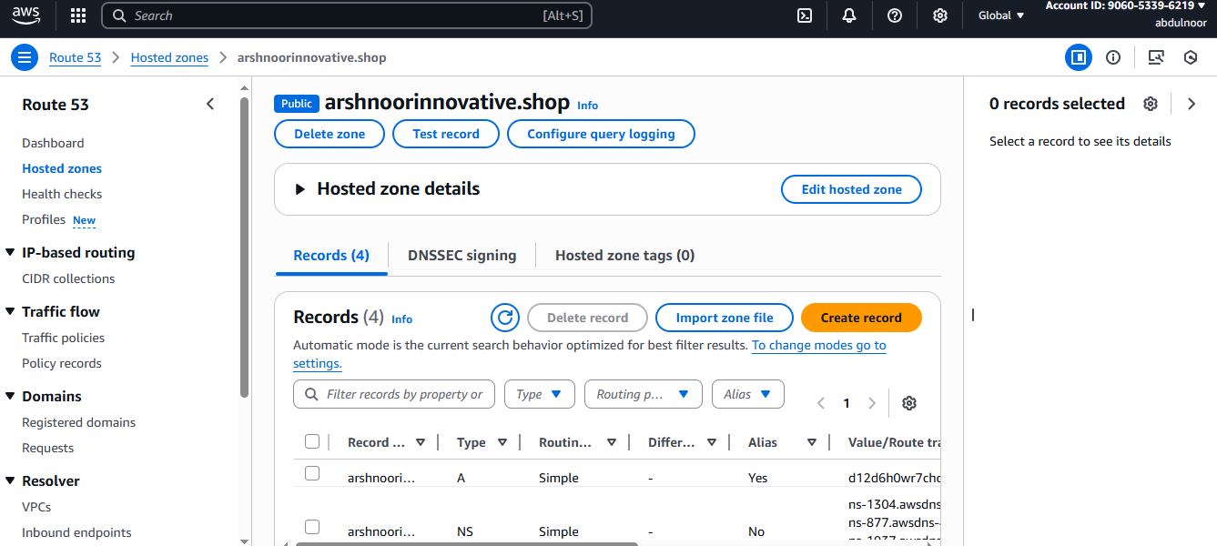

1. Push the application load balancer logs to s3

